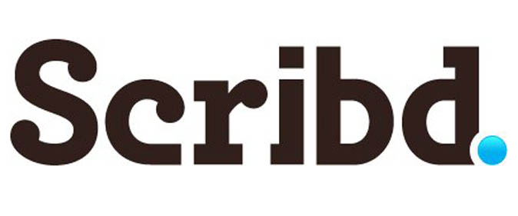
Have you ever wished that there was a Netflix membership, but for books? Well, you are in luck, dear readers, because such a membership does exist and I am so excited to be working with Scribd today to share about this amazing ebook subscription service that costs less than one paperback book a month! Not only am I chatting it up about how awesome Scribd is, but I am giving away one 6-month membership and I am offering ALL my readers an exclusive FREE 3-month trial membership to give it a try yourself.
Longtime readers know that I am a big reader and I often use the e-book library book lending services that our library offers. Unfortunately, many times when I check out the books from our library, they are not available and I have to be put on a waiting list until the next available copy comes in. It definitely puts a damper on that immediate gratification that ebooks provide.
With Scribd you have unlimited access to over 100,000 books (and counting!) from over nine hundred publishers including HarperCollins, Kensington, Open Road Media, & New World Library. These books are available across all the major ebook reading devices including iPhone, iPad, IOS, Android & the Barnes & Noble Nook tablet. Not only that, but all of these devices offer syncing to the exact page you are reading across all of these platforms.
The subscription is priced at $8.99 per month and includes nonfiction books (like cookbooks) , young adult books, and children’s books. Basically, your entire family can benefit from this service, all with the cost of just one membership.
Now that we have covered the basics, let’s dive into my own personal experience with Scribd.
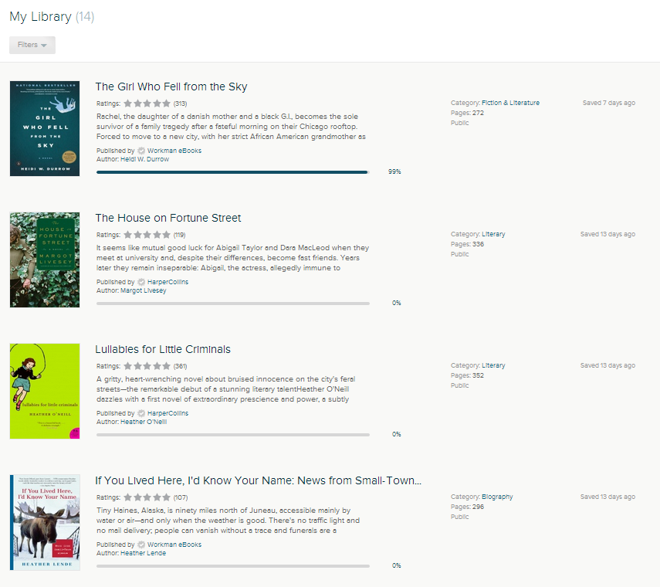
Create Your Own Personal Library Shelf
Creating a library is very easy and Scribd really makes it easier by offering recommendations based upon other books you are reading or have in your library list, much like your experience with online book purchases. Once you decide what you might like to add to your library, you just open up the book and read it. I love taking advantage of the ability to read these books when wifi is not available by adding them to my cloud. As a busy mom who is running her kids all over, this is a big plus for me because I am able to access my books anywhere regardless of the internet situation around me!
As someone who travels a lot and is always worried I won’t have enough reading material with me or that my device won’t be able to sync from our library’s ebook offerings, I love that you can download up to ten books to read offline when you are traveling or when you are somewhere without wifi access. I can already imagine how useful that will be on road trips with my children.

Read on the Go On Your Phone
I do the majority of my ebook reading on my iPad, but there are those moments where I am standing in line waiting, waiting for my kids at the bus stop, or find myself in the doctor’s office waiting room without my iPad with me. I love that Scribd also offers a mobile app that syncs with my iPad, giving me the chance to take advantage of those little moments to continue reading my book.
A Subscription Service for the Whole Family
This subscription isn’t just for me though, this is a subscription for the entire family. I love that I can start a new nighttime tradition with my kids and read one of the many kid & family book offerings that are available through the Scribd service. For example, there are numerous Beverly Clearly books for my daughter, the Warrior Cats series for my son, loads of nonfictional geeky-goodness for my hubby, and I can even explore some great cookbooks and DIY books all through our one membership. Since you can save content on up to six devices in your home, you can really make the most of your membership for your entire family.
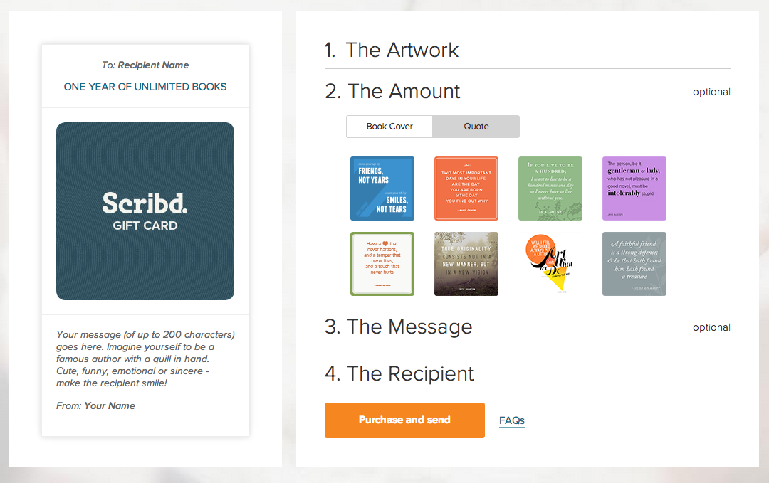
It’s a Great Gift for Anyone On Your List
If you are looking for a gift for that person on your list that has everything, the gift of a Scribd subscription is the perfect gift to share with them. You can select a 1 month subscription for $10, 3 months for $25, 6 months for $50, or 1 year for $100. The gift cards are beautifully designed which makes the giving of a subscription even more fun!
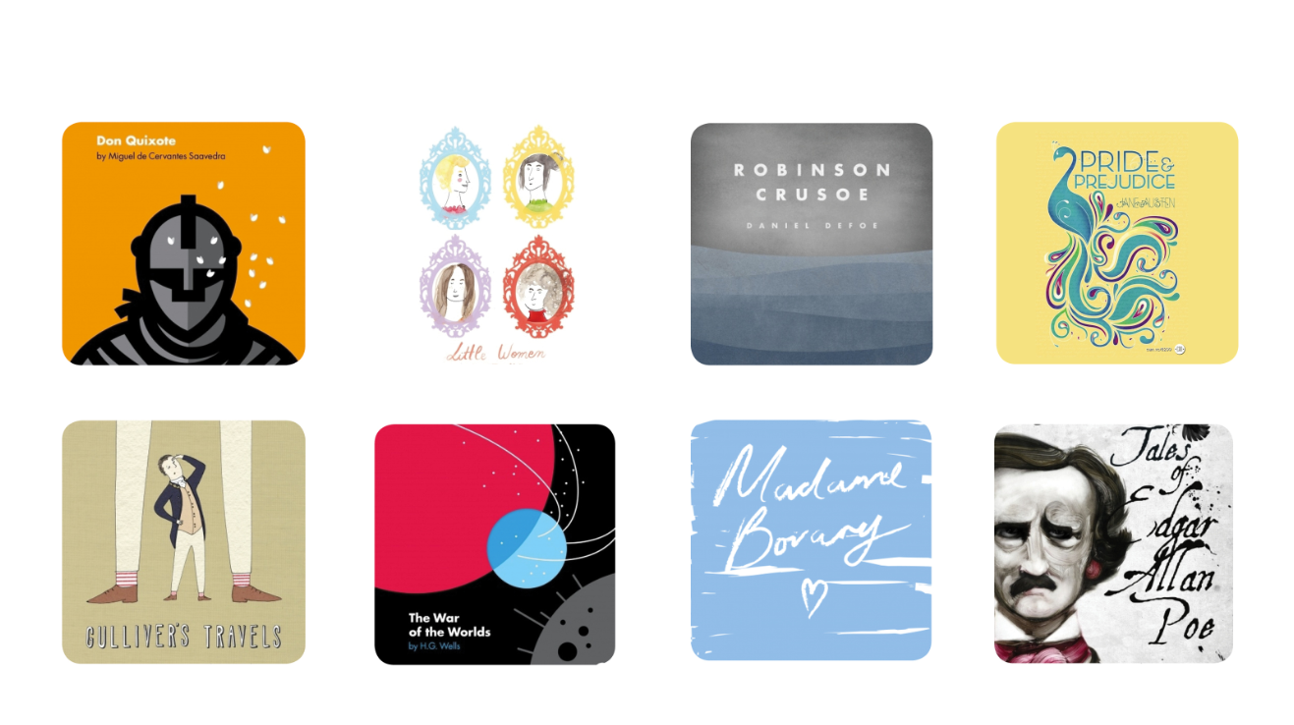
The best part about the gift cards is that you can choose from fantastic quotes from books or from these gorgeously redesigned classic book covers. Doesn’t that Little Women cover make your heart go pitter-patter?
Everyone is a Winner Here!
Even if you aren’t the winner for our six month membership contest below, EVERY MomAdvice reader can receive a free three month trial membership by using our exclusive access code. I’m so excited for you to try this service and I just know that you will love it as much as I do!
Giveaway for MomAdvice Readers
Today we are offering one lucky reader a six month subscription to Scribd Follow the instructions provided by the PromoSimple widget below to enter to win!

Embedding Code:
<img src="http://ec2-54-244-107-86.us-west-2.compute.amazonaws.com/tracker.php?cid=00DE0000000eHXcMAM&pixel=1E000000LcMjtIAF" alt="Tracking Pixel"></img>

